How list prices in Product Finder works

The Excel sheet in this folder contains prices that are included in the products database for the Ref Tools.

The prices for each sales org are included in a separate sheet.

The sheet "Configurations" is used to define which sales orgs we are including the prices for.

How to update the prices (Every Monday by data team)
- Open the document 'List prices' in folder 'Prices (public) in the RefTools folder.
- Go to sheet 'List prices' and press 'Analysis' tab -> 'Refresh all'
- Go to the assembly file and refresh as well
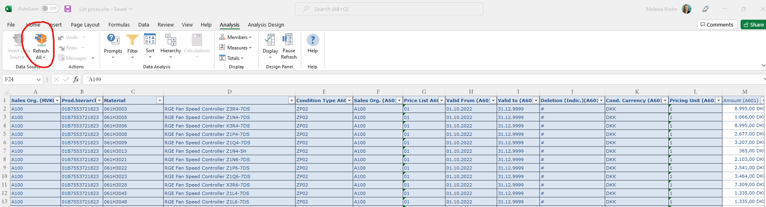

How the filters work (Explanation)
'Valid to' filter in prompts is equal or higher than current date. The document therefore shows current and future prices.
To make sure that we don’t show future prices, we have setup some rules for the assembly file.
The rules say that;
- The 'Valid from' values need to be earlier than current date
AND
- The ‘Valid to’ values need to be later than current date.
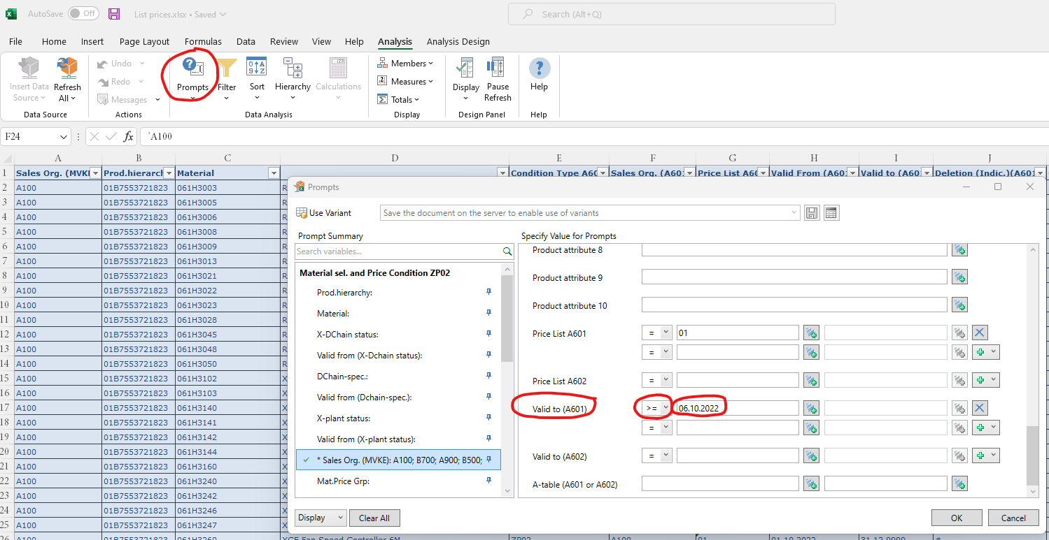
In that way the assembly file always reads the current price available at the time of the update.

Add more countries (Only after sign-off from Melessa Krohn)
When we would like to add more countries, we'll follow these steps:
- Open the document 'List prices' in folder 'Prices (public) in the RefTools folder.
- Go to sheet 'List prices' and press 'Analysis' tab -> 'Prompts'
- Scroll down to 'Sales Org.' and press +
- Add the sales org ID in the extra line
- Press 'ok'
- Add the sales org ID and currency to the table in configurations tab
- Press 'Refresh all'
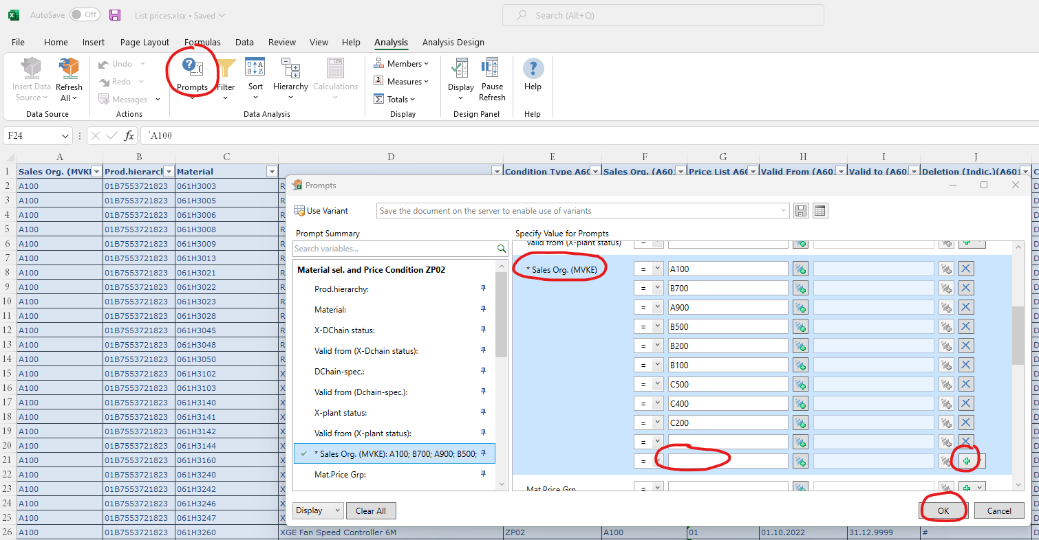
When adding prices for more sales orgs, inform the developers to allow those prices to be displayed in the product finder in the production environment.

Contact information’s
Digital Sales – Product Owner of Product Finder
Melessa Krohn

Data quality team – Updates prices weekly
Lyudmila Aliyeva

Danfoss Pricing team – Provides data source to list price documents
Michal Czapla

